**FedEx XD Design System**

**Abstract**

The industrial internet demands an industrial strength design system. Static style sheets, redline design comps and other design artifacts don’t work at scale because they don’t work directly in code.

Code is the single source of truth on the web because it’s the language of the web. Anything else needs to be translated into code spawning an inefficient work flow prone to errors.

The outcome is predictable: design systems that are difficult to use, difficult to maintain and soon abandoned.

Fortunately, HTML5 provides a way for software development teams to work in real code by using custom web components.

With custom components designers and developers speak the same language: no translation required. Style sheets become living documents and designers build software as **flexible modules** rather than rigid page templates.

Major companies like GE, Gannett and others already use web components for their design systems. And custom web elements are fully supported in Chrome, Safari and Edge with an easy way to upgrade older browsers as well.

**Case Study: GE Predix**

Predix is an important software initiative by GE in the industrial internet of things (iOT). Predix ships with a design system built from custom web components. Here’s a sample from their on-line style sheet:

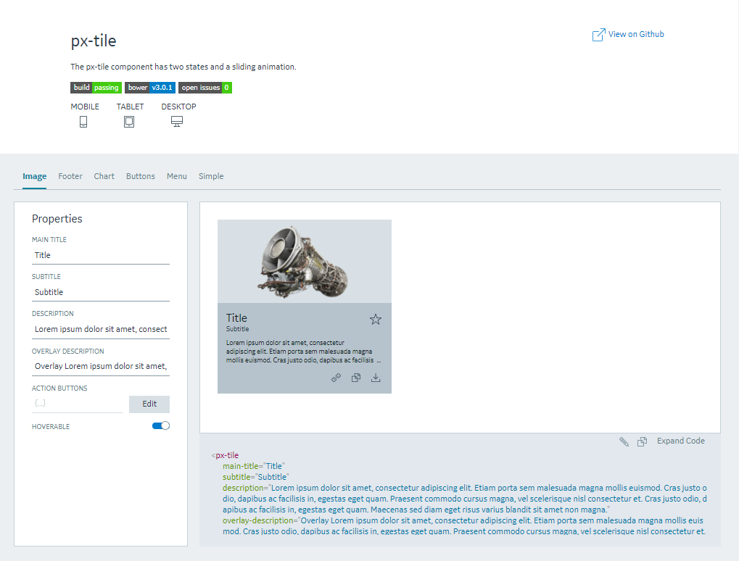

Designers and developers alike can experiment with these custom components right on the page by setting properties in the left hand column. It’s fully interactive because it’s real code.

To use this component on a web page only requires a simple tag: <px-tile></px-tile>. This simple html tag encapsulates and replaces many lines of page code. Custom components support html attributes, styles, properties, methods and events all detailed in the Predix style guide. Because there just like all the other tags that make up a web page, custom web components work well with any framework like Angular, React, Meteor, jQuery or Bootstrap.

**Proof Of Concept: Designing With Web Components**

We might want to give considereation to building a custom IDE for designers to easily compose software using FedEx components. Here’s a proof of concept.

Designers select from a menu of custom FedEx components working in a simple to use, drag and drop IDE. They start from an empty canvas using a material design grid, or not. This image shows a number of proof of concept components that have been added to the canvas and into a grid. As designers layout pages visually the IDE generates real code. Designers don’t have to deal with code and developers no longer have to second guess designer intent.

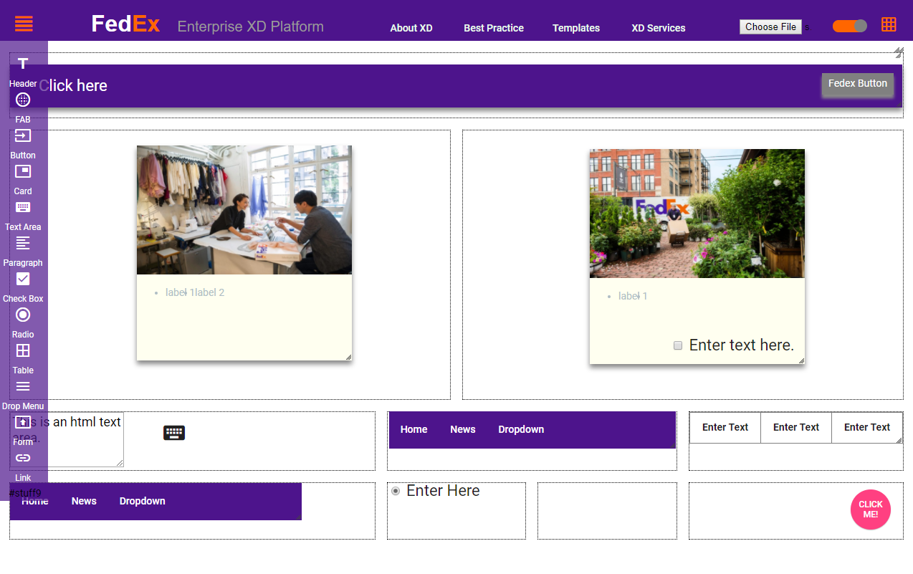

In addition to an IDE design tool, the team will have on-line access to a Predix style interactive style guide with detailed technical details and implementation guides.